Security footage shows that there were 2 witnesses.

The first witness lives at the last house on "Northwestern Dr".
14887 Morty Schapiro 118009 4919 Northwestern Dr
I heard a gunshot and then saw a man run out. He had a "Get Fit Now Gym" bag. The membership number on the bag started with "48Z". Only gold members have those bags. The man got into a car with a plate that included "H42W".

The second witness, named Annabel, lives somewhere on "Franklin Ave".
16371 Annabel Miller 490173 103 Franklin Ave
I saw the murder happen, and I recognized the killer from my gym when I was working out last week on January the 9th.

48Z7A 20180109 1600 1730 48Z7A 28819 Joe Germuska
48Z55 20180109 1530 1700 48Z55 67318 Jeremy Bowers

48Z55 20180109 1530 1700 48Z55 67318 Jeremy Bowers 20160101 gold 67318 Jeremy Bowers 423327 530 Washington Pl, Apt 3A 871539279 423327 30 70 brown brown male 0H42W2 Chevrolet Spark LS

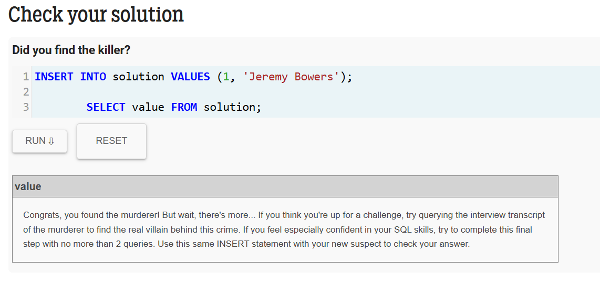

I was hired by a woman with a lot of money.
I don't know her name but I know she's around 5'5" (65") or 5'7" (67").
She has red hair and she drives a Tesla Model S.
I know that she attended the SQL Symphony Concert 3 times in December 2017.

99716 1143 SQL Symphony Concert 20171206 99716 Miranda Priestly 202298 1883 Golden Ave 987756388 202298 68 66 green red female 500123 Tesla Model S
99716 1143 SQL Symphony Concert 20171212 99716 Miranda Priestly 202298 1883 Golden Ave 987756388 202298 68 66 green red female 500123 Tesla Model S
99716 1143 SQL Symphony Concert 20171229 99716 Miranda Priestly 202298 1883 Golden Ave 987756388 202298 68 66 green red female 500123 Tesla Model S

